**Database questions**

**Having and Where clause**

Having is used to filter groups . Where clause is used to filter rows.

HAVING is to filtering the groups. If you have not GROUP BY clause, all rows presents one group. So, if predicate in HAVING evaluates as true, you get one row, otherwise no rows.

Having can be used for filtering without having Group by also but ‘where’ can’t be used to filter groups.

|  |  |
| --- | --- |
| SELECT * FROM HARVESTER HAVING SOURCE_ID = 268401860; | Correct |
| SELECT * from dual having 1 = 1; | Correct |
| select a, count(*) as c  from mytable  group by a  where c > 1; | Incorrect |
| select a, count(*) as c  from mytable  group by a  having c > 1; | Correct |

**ACID Properties:**

A: **Atomic**: All transactions in database are atomic. Either all steps of transaction completes or none of them.

C: **Consistency**, transaction must leave database in consistent state even if it succeed or rollback.

I: **Isolation**, Two database transactions happening at same time should not affect each other and has consistent view of database. This is achieved by using isolation levels in database.

D: **Durability**, Data has to be persisted successfully in database once transaction completed successfully and it has to be saved from power outage or other threats. This is achieved by saving data related to transaction in more than one places along with database.

**Nth record from table**

select salary from

(select salary from employee order by salary desc limit N)

order by salary asc limit 1;

select * from emp as e1

where N-1 = (

select count(Distinct(e2.salary)) from emp as e2

where e2.salary>e1.salary

)

SELECT Salary FROM Employee

ORDER BY Salary DESC LIMIT n-1,1

It will return 1 row starting from nth row.

Limit offset, count: offset starts with 0. If we need 1 row at position 5 in the result set then we have to write: Limit 4, 1. (4 = 5-1).

**JDBC Connection**

* Register the driver class
* Creating connection
* Creating statement
* Executing queries
* Closing connection

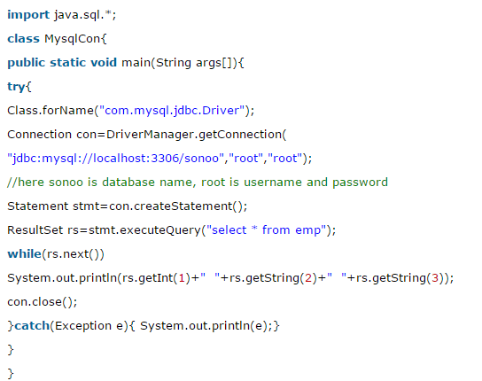

**ExecuteQuery and ExecuteUpdate**

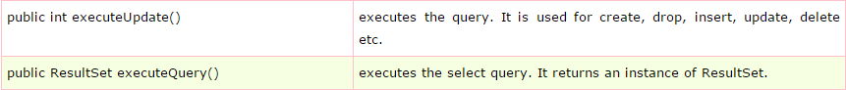

***Note: It is ExecuteUpdate not updateQuery.***

PreparedStatement

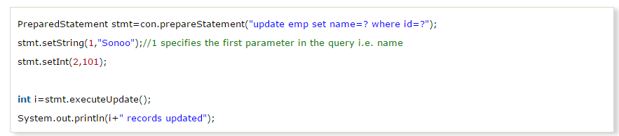

Any, All, In..SQL Operators

<https://stackoverflow.com/questions/3699356/difference-between-in-and-any-operators-in-sql>

**Primary Key vs Unique Key**

[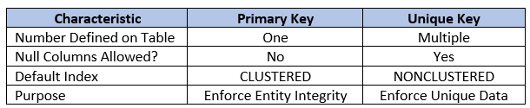](https://277dfx2bm2883ohl6u2g3l59-wpengine.netdna-ssl.com/wp-content/uploads/2017/07/PrimaryKeyVersusUniqueKey.png)

**One null value is allowed for Unique Key.

**DDL and DML**

DML

DML is abbreviation of Data Manipulation Language. It is used to retrieve, store, modify, delete, insert and update data in database.

Examples: SELECT, UPDATE, INSERT statements

DDL

DDL is abbreviation of Data Definition Language. It is used to create and modify the structure of database objects in database.

Examples: CREATE, ALTER, DROP statements

**Delete, Drop, Truncate**

**Delete**:

Delete the row/s which meets the criteria of where clause.

Can be rolled back.

Is a dml command.

**Drop**:

Drop the table from database.

Can’t be rolled back.

Is a ddl command.

**Truncate**:

Remove all the rows from table.

We can’t put it along with where clause, since it is DDl command.

Can’t be rolled back.

Is a ddl command.

Note: Truncate is ddl command as it change the watermark of the table in database. (In my language: it redefined the table in db).